The following is the test cases for the PID Analog circuit of MAX1968. Here I have changed the set point and the thermistor values sequentially in a set of pulses as seen below and monitored the output from 3 Op-Amps. U3 output is CTLI which goes to MAX1968 and U1, U2 are the 2 differential amplifiers which compare set temperature with the thermistor (Measured Value).

1. Test case simulation

Set temp – 0.5 V, Thermistor – in form of pulse{10s- rise time, 10s- fall time, 50s- ON time, VON- 0.9V, Vini- 0V}

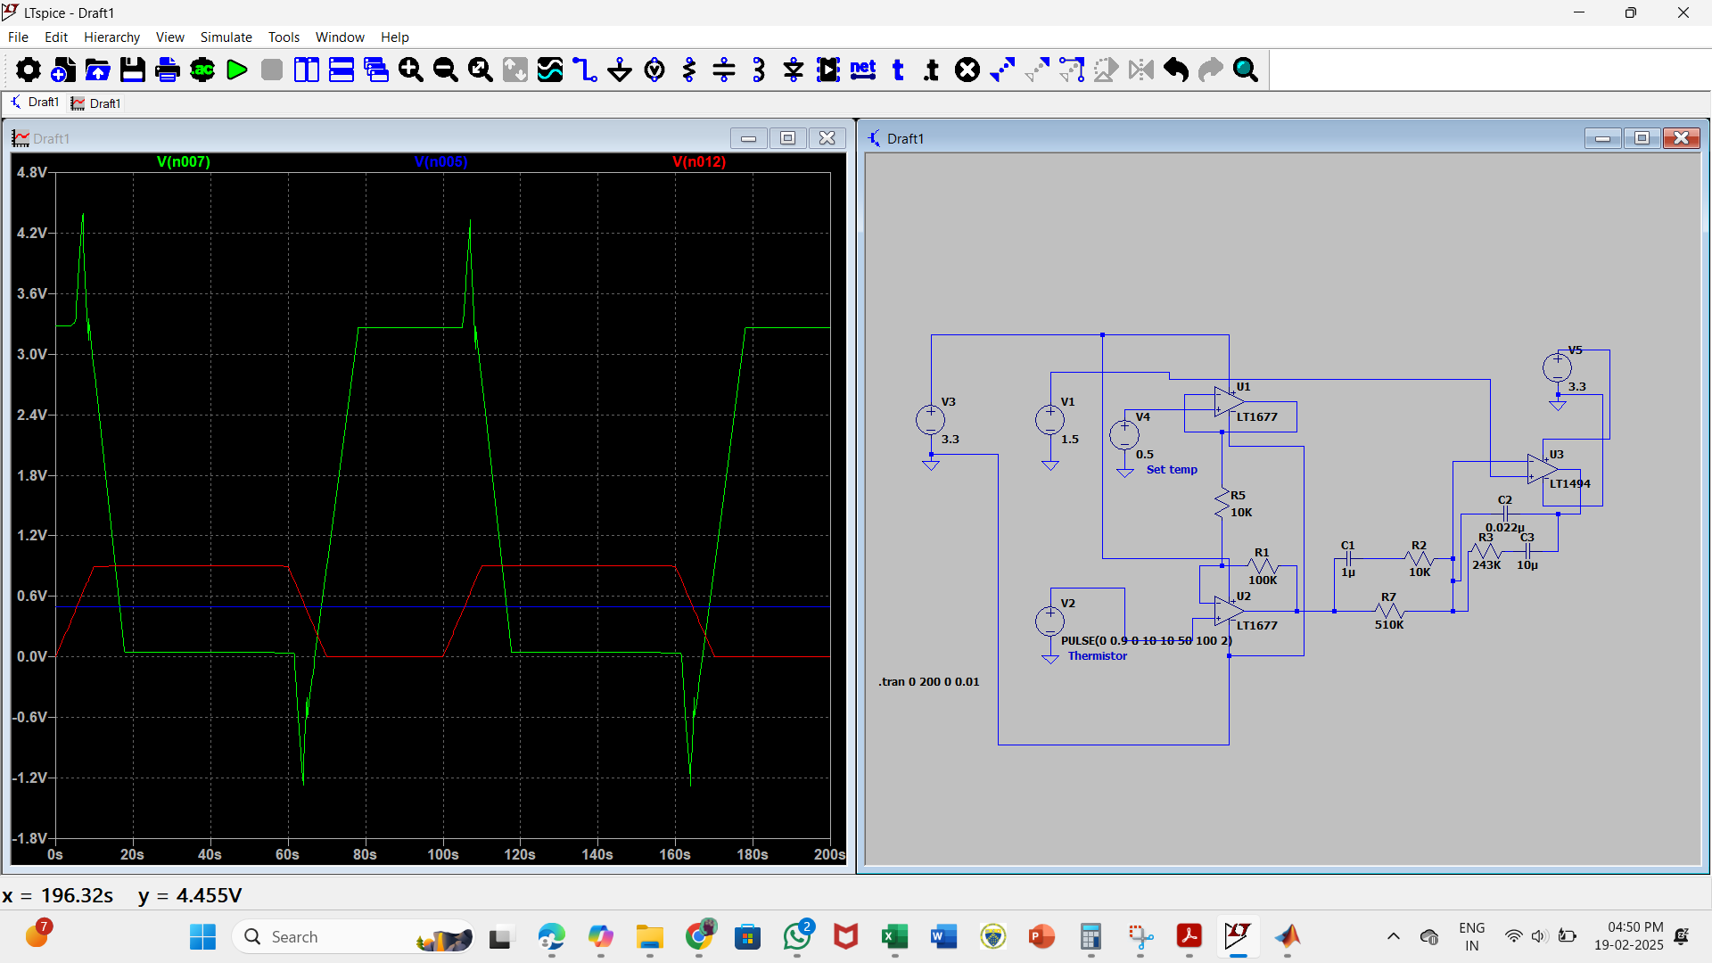

1. Test case simulation

Set temp – 0.5 V, Thermistor – in form of pulse {10s- rise time, 10s- fall time, 50s- ON time, VON- 0.4V, Vini- 0.5}

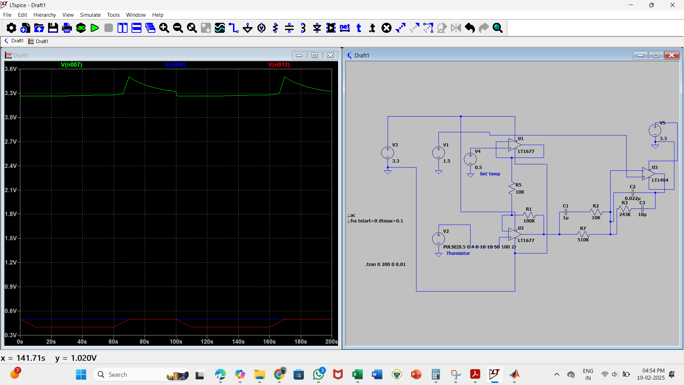

1. Test case simulation

Set temp – 0.5 V, Thermistor – in form of pulse{10s- rise time, 10s- fall time, 50s- ON time, VON- 0.6V, Vini-0.5}

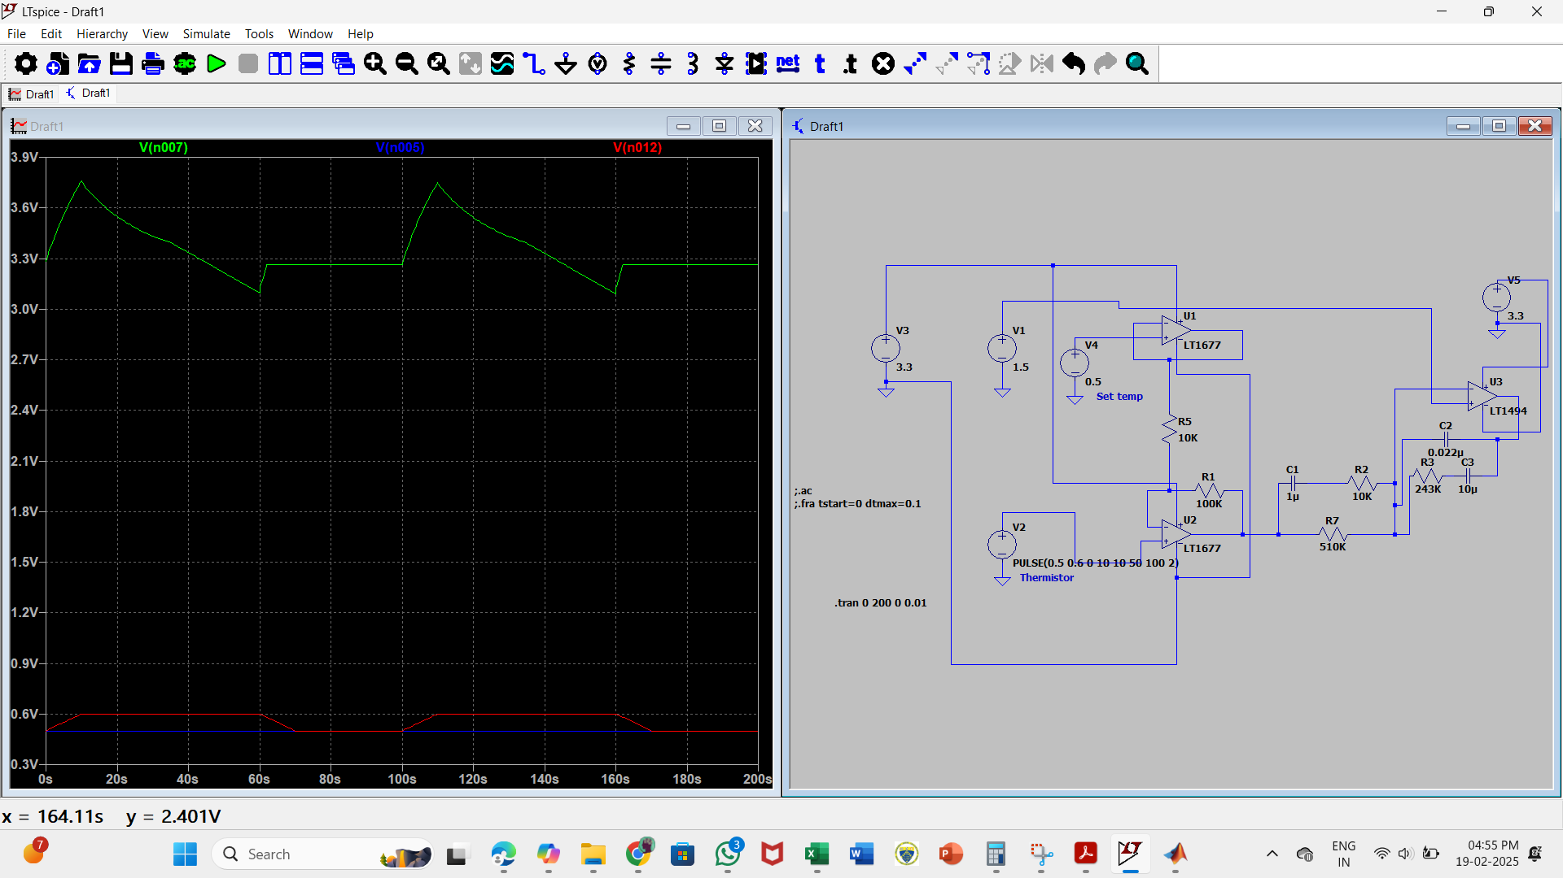

1. Test case simulation

Set temp – 0.5 V, Thermistor – in form of pulse{10s- rise time, 10s- fall time, 50s- ON time, VON- 1.0V, Vini-0.5}

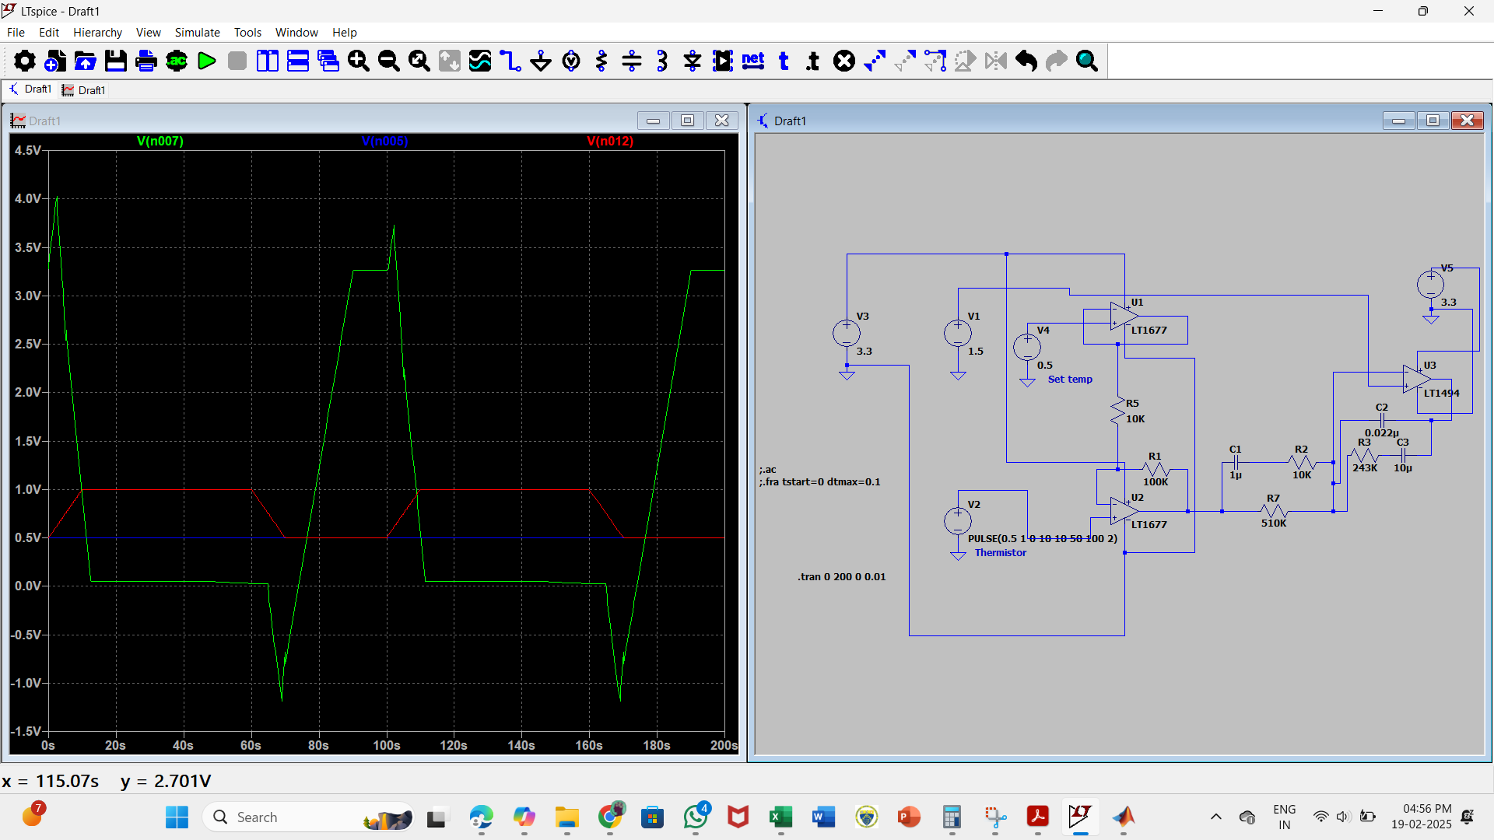

1. Test case simulation

Set temp – 0.5 V, Thermistor – in form of pulse{10s- rise time, 10s- fall time, 50s- ON time, VON- 0V, Vini-0.5V}

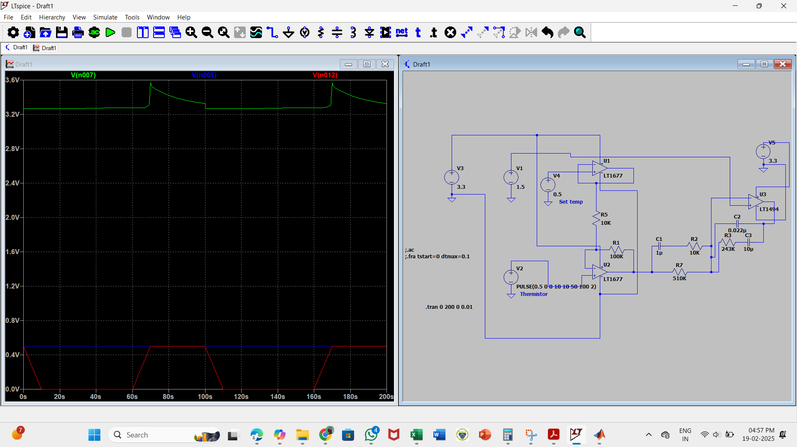

1. Test case simulation

Set temp – 1 V, Thermistor – in form of pulse{10s- rise time, 10s- fall time, 50s- ON time, VON- 1.5V, Vini-0V}

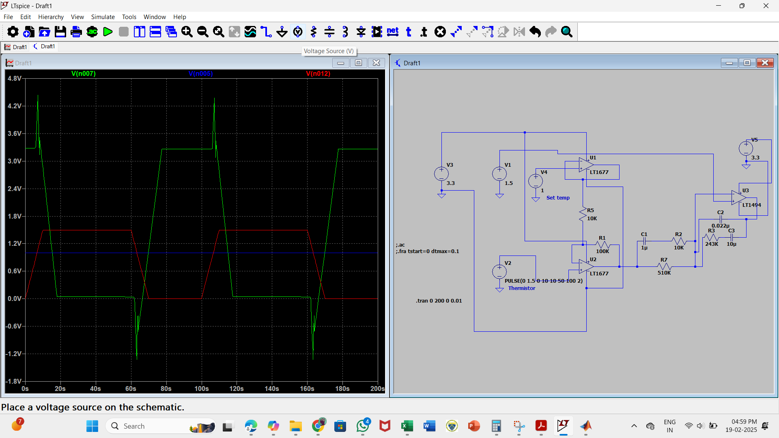

1. Test case simulation [Servo regulation]

Set temp – in form of pulse {10s- rise time, 10s- fall time, 50s- ON time, VON- 1.0V, Vini-0V}, Thermistor – 0.75v

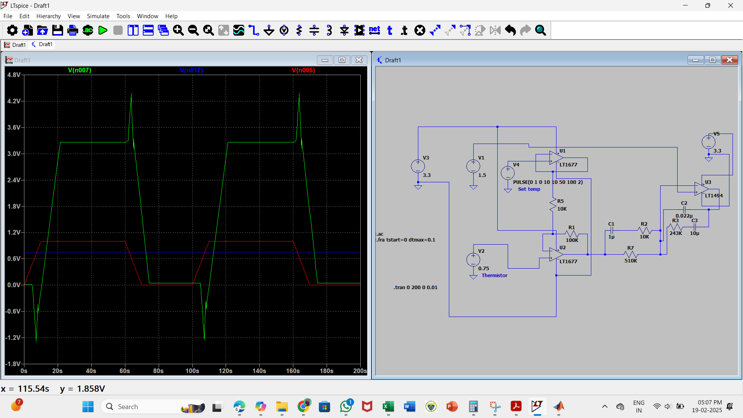

1. Test case simulation [Servo regulation]

Set temp – in form of pulse {10s- rise time, 10s- fall time, 50s- ON time, VON- 1.5V, Vini-0V}, Thermistor – 0.75v

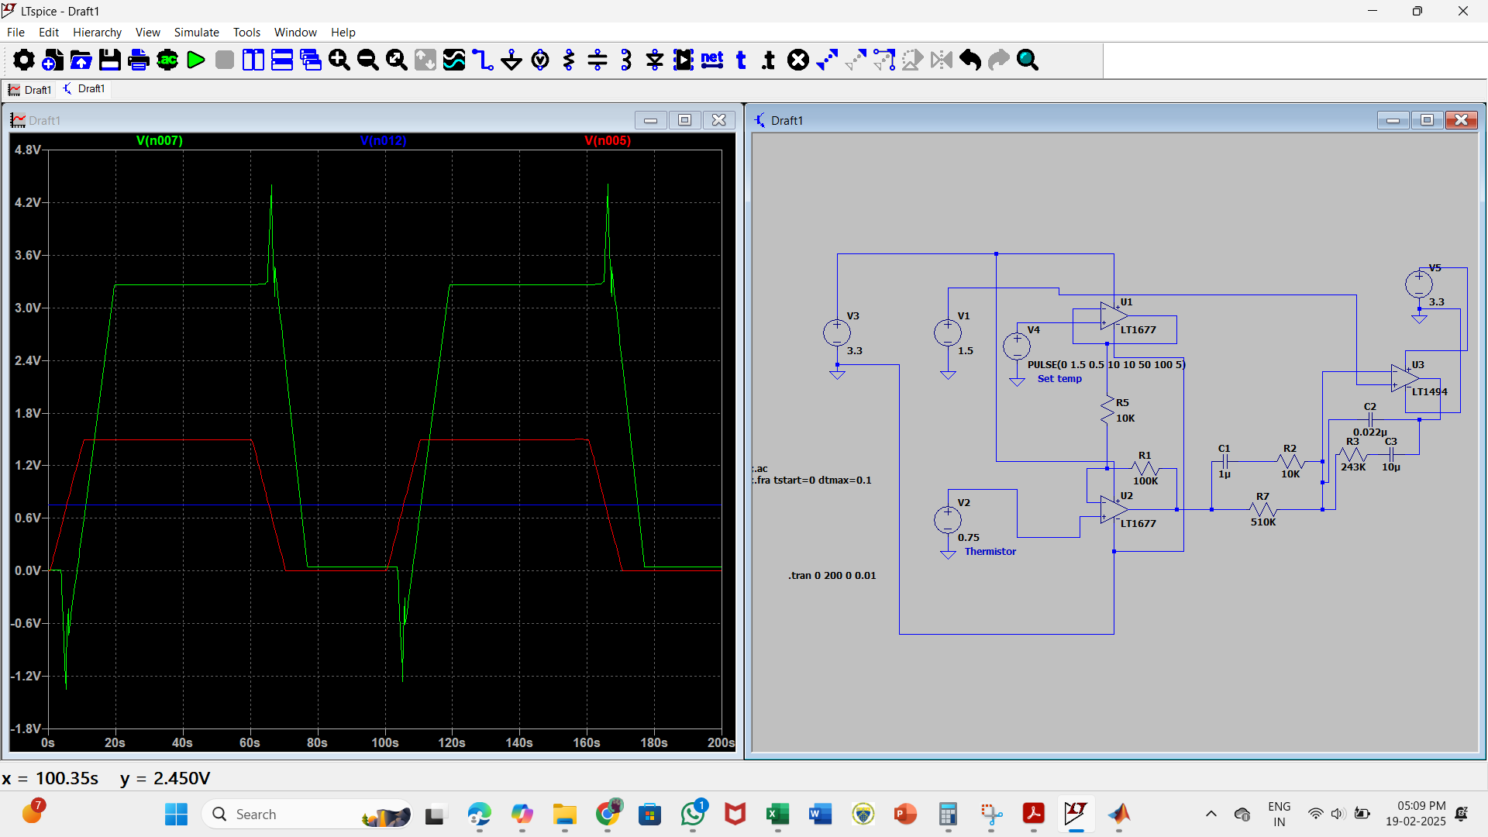

1. Test case simulation [Servo regulation]

Set temp – in form of pulse {10s- rise time, 10s- fall time, 50s- ON time, VON- 1.5V, Vini-0V}, Thermistor – 0.75v

